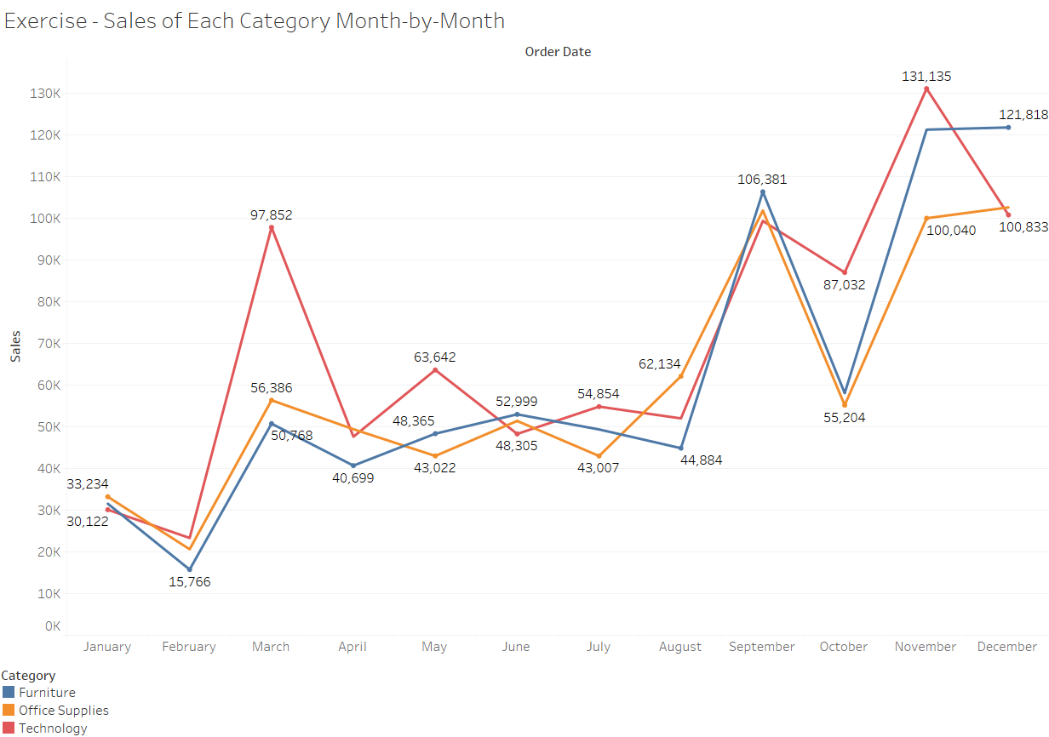

**Inference:**

**The line chart shows high rise in technology category in the month of March, September and November.**